**Model Organism Taxonomy and Evolution Database Project**

Hood College, IT/ BIFX 530-02, Fall 2022

Nicholus Vaughan, Emily Whisenhunt,

Michael Cook, J. Jedediah Smith

**Data Requirements Analysis**

Each account has a unique student ID and general information about the user. They must be associated with an institution, as this relationship is what will grant access to the database.

Each institution has a unique institute ID to distinguish places with similar names. They must purchase a set number of licenses for a set period to grant their students access to the database. Should the license expire, their student accounts will be deleted. Should their licenses be used up, new student accounts cannot be associated with that institution.

Saved searches are searches an account has made that they wish to revisit in the future. This just saves the search ID in an easy to access place. Account may have numerous saved searches.

Each search has a unique search ID and a date so it can be easily referenced. The key words are what will be used to find various species for the search results display.

Each species has a unique scientific name (e.g., Mus musculus). The other attributes for species include ploidy and reproductive rate for the model organism. These are important attributes that help establish their value as model organisms.

Each MRCA (most recent common ancestor) must be associated with one species and vice versa. The MRCA entity contains the name of the ancestor and the estimated time (in MYA, millions of years ago) that the ancestor lived.

**ER Diagram**

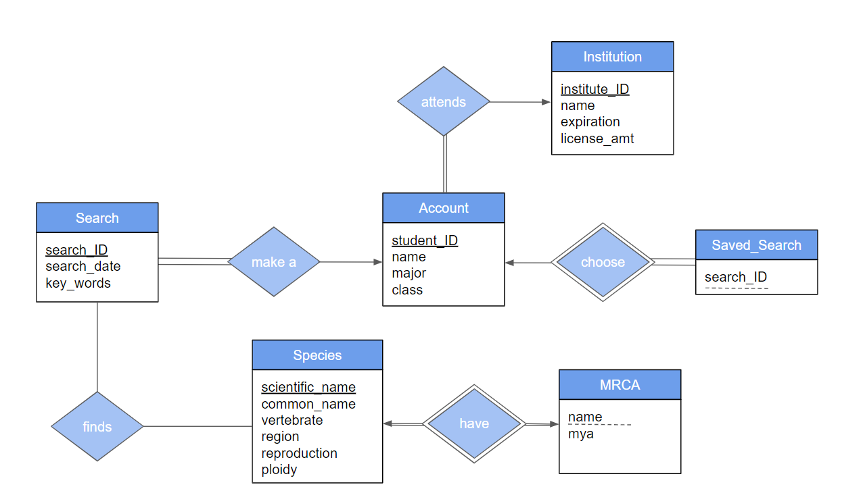

**Assumptions**

1. Each Account must be associated with one Institution. Institutions may have multiple accounts.
2. Each Search is made by one account. One account may make zero, one, or many searches.
3. Each Search may find multiple Species. Each Species may be found by multiple searches.
4. Saved_Searches must be associated with one Account. One Account may be associated with multiple saved searches.
5. Each Species has one MRCA. Each MRCA is associated with one Species.